# OVERVIEW

* C++ is an object oriented language based on the C programming language.
* It can be viewed as a super set of C. Almost all of the features and constructs available in C are available in C++. However C++ is more than just an extension of C. Its additional features support the programming style known as Object Oriented Programming (OOP).
* Several features that are already available in C, such as Input and output may be implemented differently in C++.
* In C++ you may use the conventional C Input and Output routines or you may use Object Oriented Input and Output by using I/O stream library.
* Its additional features support the programming style known as Object Oriented Programming (OOP).
* Object oriented programming is a programming style that is associated with the concept of Class, Objects and various other concepts revolving around these two, like Inheritance, Polymorphism, Data Abstraction, Encapsulation etc.
* Encapsulation is the process of binding up of data and function into a single entity
* Abstraction is the process of representing only the essential features hiding the background details.
* Inheritance is the capability of one class to inherit the properties from another class.
* Polymorphism is the characteristic of being able to assign a different meaning or usage to something in different contexts.

# ABSTRACT

* + The project provides a user friendly, way of sending messages.
  + The need for the project is to communicate with other users.
  + With the growing stress in human beings all around the world, people very rarely find time for themselves to talk.
  + Thus, this program provides a source of fun communication.
  + This program is simple excellent way to chat

with people to communicate real-time with everyone..

# HARDWARE AND SOFTWARE REQUIREMENTS

**HARDWARE REQUIREMENT:**

* + Computer
  + 1.50Ghz processor
  + Hard disk
  + 30+MB ROM Compact Disk(optional)
  + RAM-512MB
  + Memory Requirement:1MB
  + Processor Speed:1.2GHz
  + Resolution:1336x768

**SOFTWARE REQUIREMENT:**

* + Turbo C++ Version 3.0/Dos box version 0.77
  + Notepad
  + Windows 7 or 8

**INSTALLATION OF APPLICATION:**

Insert the ROM CD which contains the application into the CPU.Scan the CD for malicious objects.Copy the contents in the CD to your system.Now,you can run the application

**Header Files**

* #include<fstream.h> -This is used for Input Output Operations.
* #include<conio.h> -This is used to provide console Input and Output.
* #include<string.h> -This is used to manipulate string or character array.
* #include<stdio.h> -This is used to provide Standard Input Output functions.

# CLASS AND FUNCTIONS:

class mails

{

private:

char mail[50]; char email[50]; char pass[50]; char sub[50]; char mess[100]; char emailid[50];

char fname[20],lname[20],uname[50]; char password[20];

char password1[20]; int dd,mm,yr;

long double phoneno; char address[20];

int otp,code; public:

void mail1()

{

cin>>mail;

}

void email1()

{

cin>>email;

}

void pass1(char c[50])

{

strcpy(pass,c);

}

void sub1()

{

cin>>sub;

}

void mess1()

{

cin>>mess;

}

void emailid1()

{

cin>>emailid;

}

void fname1()

{

cin>>fname;

}

void lname1()

{

cin>>lname;

}

void uname1()

{

cin>>uname;

}

void pd(char r[50])

{

strcpy(password,r);strcpy(password1,r);

}

void password2(char s[50])

{

strcpy(password,s);

}

void password3(char p[50])

{

strcpy(password1,p);

}

void date1()

{

cout<<"\n date:";

cin>>dd; cout<<"\n month:"; cin>>mm; cout<<"\n year:"; cin>>yr;

}

void pno1()

{

cin>>phoneno;

}

void address1()

{

cin>>address;

}

void otp1()

{

cin>>otp;

}

void code1(int y)

{

code=y;

}

char *username5()

{

return uname;

}

char *el5()

{

return email;

}

char *psd5()

{

return password;

}

char *firstname5()

{

return fname;

}

char *lastname5()

{

return lname;

}

char *password15()

{

return password1;

}

}m[50];

class message

{

char message[800],subject[60],sender[20],receiver[20]; public:

char *receive()

{

return receiver;

}

char *send()

{

return sender;

}

void disp()

{

cout<<"\n from :"<<sender; cout<<"\n to :"<<receiver; cout<<"\n subject :"<<subject; cout<<"\n message :"<<message;

}

void getmess()

{ clrscr();

cout<<"\n from :"<<::a; strcpy(sender,::a); cout<<"\n to:"; cin>>receiver; cout<<"\n subject :"; cin>>subject; cout<<"\n message:"; cin>>message;

cout<<"\n \t\t\t\t\t send"; getch();

}

};

void disp_gmail(); void signup(); void signin(); void display();

void password_change(); void compose();

void inbox(); void outbox();

# SOURCE CODE:

#include<fstream.h> #include<conio.h> #include<string.h> #include<stdio.h> char a[50];

int k=0; int z=0; int j=0; int i=0; int p=0;

class mails

{

private:

char mail[50]; char email[50]; char pass[50]; char sub[50]; char mess[100]; char emailid[50];

char fname[20],lname[20],uname[50];

char password[20]; char password1[20]; int dd,mm,yr;

long double phoneno; char address[20];

int otp,code; public:

void mail1()

{

cin>>mail;

}

void email1()

{

cin>>email;

}

void pass1(char c[50])

{

strcpy(pass,c);

}

void sub1()

{

cin>>sub;

}

void mess1()

{

cin>>mess;

}

void emailid1()

{

cin>>emailid;

}

void fname1()

{

cin>>fname;

}

void lname1()

{

cin>>lname;

}

void uname1()

{

cin>>uname;

}

void pd(char r[50])

{

strcpy(password,r);strcpy(password1,r);

}

void password2(char s[50])

{

strcpy(password,s);

}

void password3(char p[50])

{

strcpy(password1,p);

}

void date1()

{

cout<<"\n date:"; cin>>dd; cout<<"\n month:"; cin>>mm; cout<<"\n year:"; cin>>yr;

}

void pno1()

{

cin>>phoneno;

}

void address1()

{

cin>>address;

}

void otp1()

{

cin>>otp;

}

void code1(int y)

{

code=y;

}

char *username5()

{

return uname;

}

char *el5()

{

return email;

}

char *psd5()

{

return password;

}

char *firstname5()

{

return fname;

}

char *lastname5()

{

return lname;

}

char *password15()

{

return password1;

}

}m[50];

class message

{

char message[800],subject[60],sender[20],receiver[20]; public:

char *receive()

{

return receiver;

}

char *send()

{

return sender;

}

void disp()

{

cout<<"\n from :"<<sender; cout<<"\n to :"<<receiver; cout<<"\n subject :"<<subject; cout<<"\n message :"<<message;

}

void getmess()

{ clrscr();

cout<<"\n from :"<<::a; strcpy(sender,::a); cout<<"\n to:"; cin>>receiver;

cout<<"\n subject :"; cin>>subject; cout<<"\n message:"; cin>>message;

cout<<"\n \t\t\t\t\t send"; getch();

}

};

void disp_gmail(); void signup(); void signin(); void display();

void password_change(); void compose();

void inbox(); void outbox();

void main()

{

clrscr(); remove("messag.dat"); char str[100];

cout<<"\n\n\n\n\n\n google"; cout<<"\n\n\n\n enter your search:"; cin.getline(str,100);

disp_gmail(); getch();

}

void disp_gmail()

{

clrscr(); remove("message.dat"); int ch;

g:

cout<<" GMAIL \n"; cout<<"\n 1.sign in \n"; cout<<"\n 2.sign up \n"; cout<<"\n 3.back \n"; cout<<"\n enter your choice:"; cin>>ch;

switch(ch)

{

case 1:signin();

break; case 2:signup();

break; case 3:break;

default:cout<<"enter the right choice"; goto g;

}

}

void signup()

{

clrscr(); int ch; b:

clrscr();

cout<<"\n create an account \n"; cout<<"\n FIRST NAME:";

m[::i].fname1();

cout<<"\n LAST NAME:"; m[::i].lname1();

cout<<"\n USERNAME:"; m[::i].uname1();

cout<<"\n CREATE A PASSWORD:";

int k=0;

char pass[20],c=' '; while(c!=char(13))

{

c=getch(); if(c!=char(13))

{

if(c!='\b')

{

cout<<"*"; pass[k]=c; k++;

}

else

{

k--;

}

}

}

pass[k]='\0'; m[::i].password2(pass);

cout<<"\n\n CONFIRM YOUR PASSWORD:";

int u=0;

char as[20],h=' '; while(h!=char(13))

{

h=getch(); if(h!=char(13))

{

if(h!='\b')

{

cout<<"*"; as[u]=h; u++;

}

else

{

u--;

}

}

}

as[u]='\0'; m[::i].password3(as);

if(strcmp(m[::i].psd5(),m[::i].password15())==0)

{

cout<<"\n\n ENTER YOUR BIRTH DATE";

m[::i].date1(); cout<<"\n GENDER"; cout<<"\n1.male"; cout<<"\n2.female"; cout<<"\n3.others";

cout<<"\n choose your gender:"; cin>>ch;

cout<<"\n MOBLE PHONE NUMBER:+91-";

m[::i].pno1();

cout<<"\n LOCATION:"; m[::i].address1();

cout<<"\n continue \n"; getch();

}

else

{

cout<<"\n password mismatch ";

getch(); goto b;

}

clrscr();

cout<<"\n enter your otp:"; m[::i].otp1();

cout<<"\n otp verified"; m[::i].code1(::i);

::i++;

cout<<"\n sign up"; getch();

clrscr();

signin();

}

void signin()

{

clrscr(); int j=0; int i=0; fg:

clrscr();

cout<<"\n\n\n sign in"; cout<<"\n ENTER YOUR EMAIL:";

m[::z].email1();

cout<<"\n ENTER YOUR PASSWORD:";

int k=0;

char pass[20],ch=' '; while(ch!=char(13))

{

ch=getch(); if(ch!=char(13))

{

if(ch!='\b')

{

cout<<"*"; pass[k]=ch; k++;

}

else

{

k--;

}

}

}

pass[k]='\0'; m[::z].pass1(pass);

for(i=0;i<=::i;i++)

{

if(strcmp(m[::z].el5(),m[i].username5())==0)

{

j=i;

}

}

if(strcmp(m[j].psd5(),pass)==0)

{

cout<<"\n\n sign in"; strcpy(::a,m[::z].el5());

::z++;

::j++;

getch();

clrscr(); display();

}

else

{

cout<<"\n wrong password"; getch();

goto fg;

}

}

void display()

{

clrscr(); int ch;

for(int k=0;k<=::i;k++)

{

if(strcmp(::a,m[k].username5())==0)

{

cout<<"\n name : "<<m[k].firstname5()<<" "<<m[k].lastname5(); cout<<"\n email : "<<m[k].username5();break;

}

}

cout<<"\n1.compose \n2.inbox \n3.password change \n4.outbox \n5.logout"; cout<<"\n enter your choice:";

cin>>ch; switch(ch)

{

case 1:compose(); break;

case 2:inbox();

break;

case 4:outbox();break; case 3:password_change();

break;

case 5:cout<<"\n log out"; disp_gmail(); break;

default:cout<<" ";

}

}

void password_change()

{

char sf[50]; clrscr();

hj:

cout<<"\n ENTER YOUR PASSWORD:";

int u=0;

char as[20],h=' ';

while(h!=char(13))

{

h=getch(); if(h!=char(13))

{

if(h!='\b')

{

cout<<"*"; as[u]=h; u++;

}

else

{

u--;

}

}

}

as[u]='\0';

for(int i=0;i<=::i;i++)

{

if(strcmp(::a,m[i].username5())==0)

{

j=i; break;

}

}

if(strcmp(as,m[j].password15())==0)

{

cout<<"\n\n enter new password:"; int k=0;

char pass[20],ch=' '; while(ch!=char(13))

{

ch=getch(); if(ch!=char(13))

{

if(ch!='\b')

{

cout<<"*"; pass[k]=ch; k++;

}

else

{

k--;

}

}

}

pass[k]='\0';

m[j].pd(pass);

}

else

{

cout<<"\n type the correct password"; goto hj;

}

display();

}

void compose()

{

message m;

ofstream fo("messag.dat",ios::binary|ios::app); m.getmess();

fo.write((char*)&m,sizeof(m));

fo.close(); display();

}

void outbox()

{

ifstream fi("messag.dat",ios::binary); message m; while(fi.read((char*)&m,sizeof(m)))

{

if(strcmp(::a,m.send())==0)

{

m.disp(); cout<<"\n";

}

}

getch();

fi.close(); display();

}

void inbox()

{

ifstream fi("messag.dat",ios::binary); message m; while(fi.read((char*)&m,sizeof(m)))

{

if(strcmp(::a,m.receive())==0)

{

m.disp(); cout<<"\n";

}

}

getch();

fi.close(); display();

}

# Output:

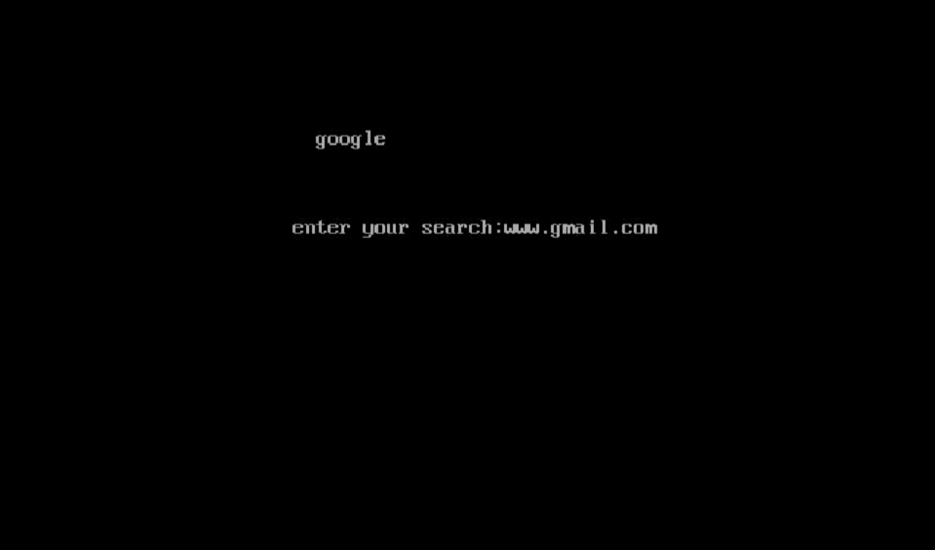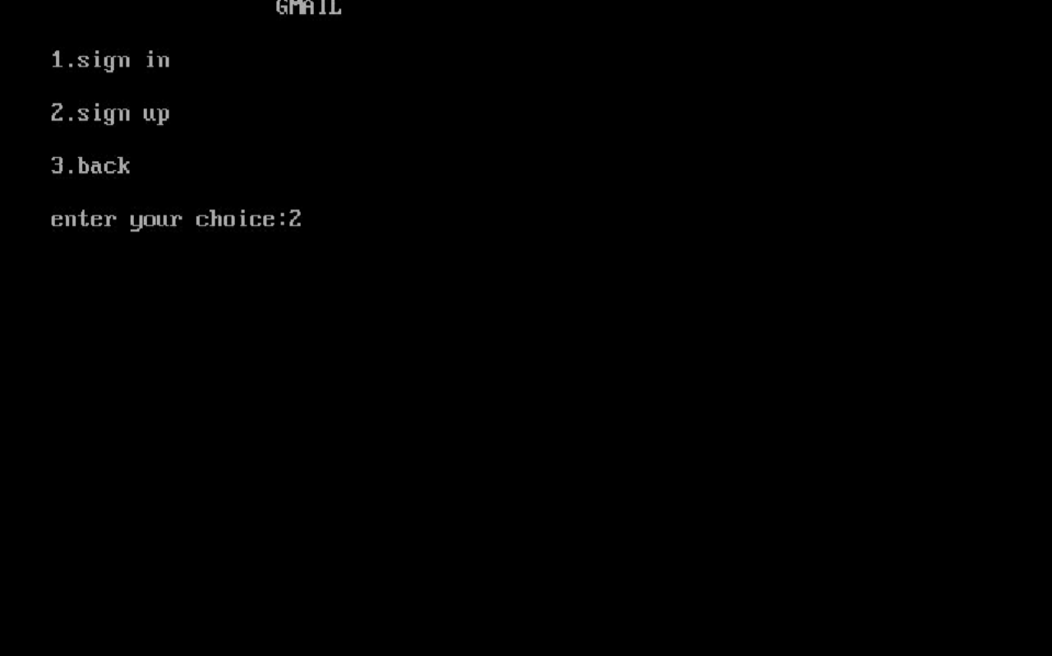

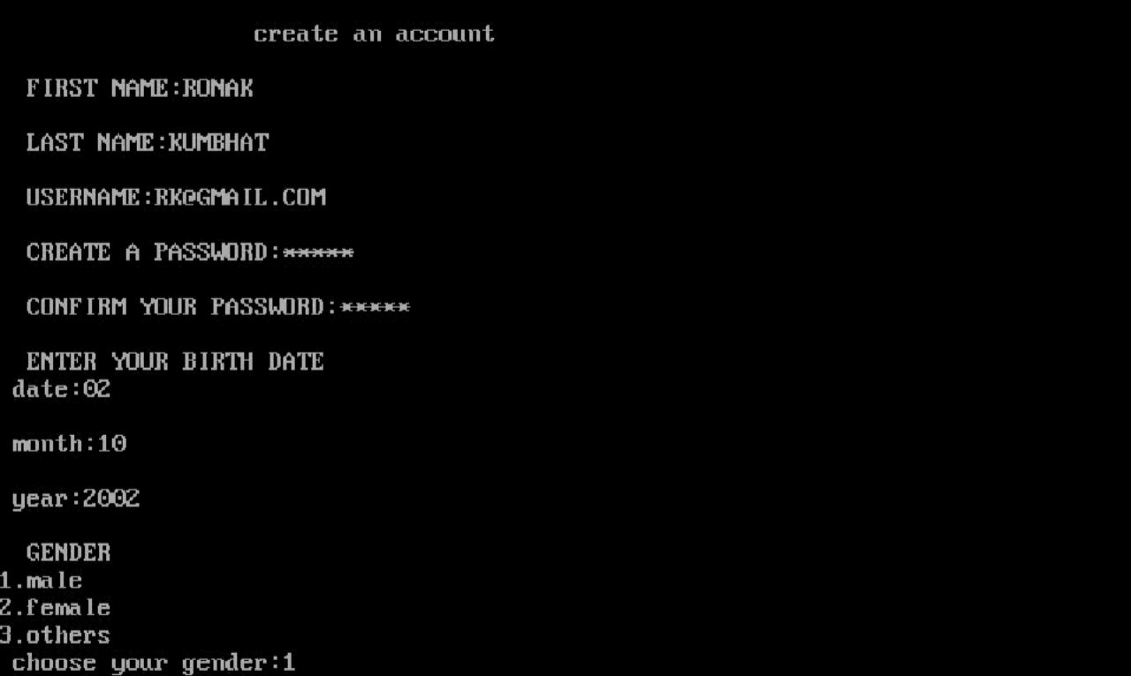



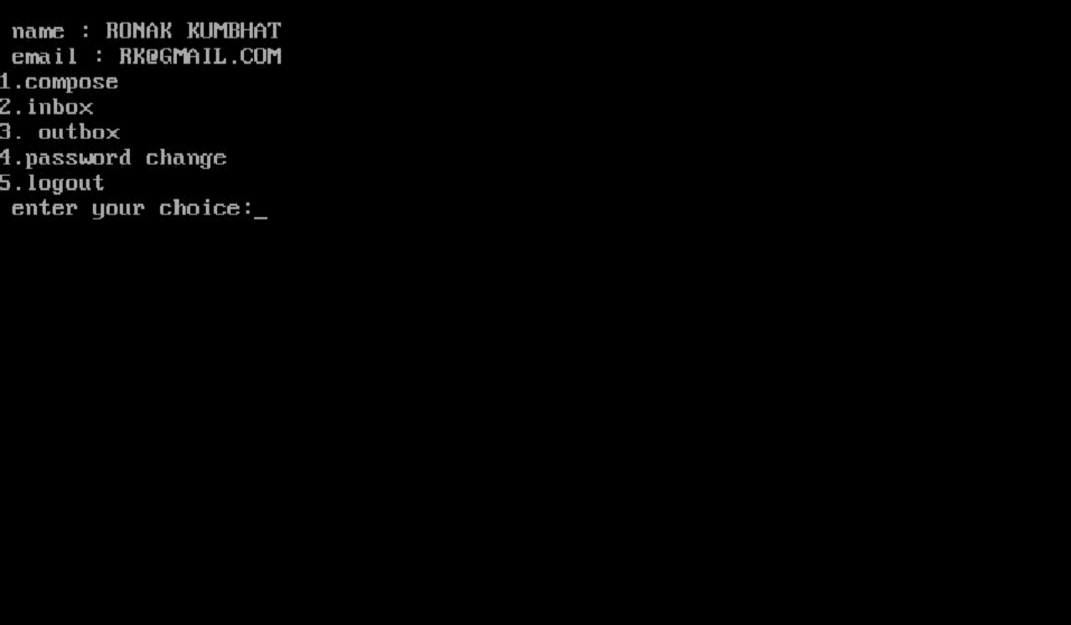

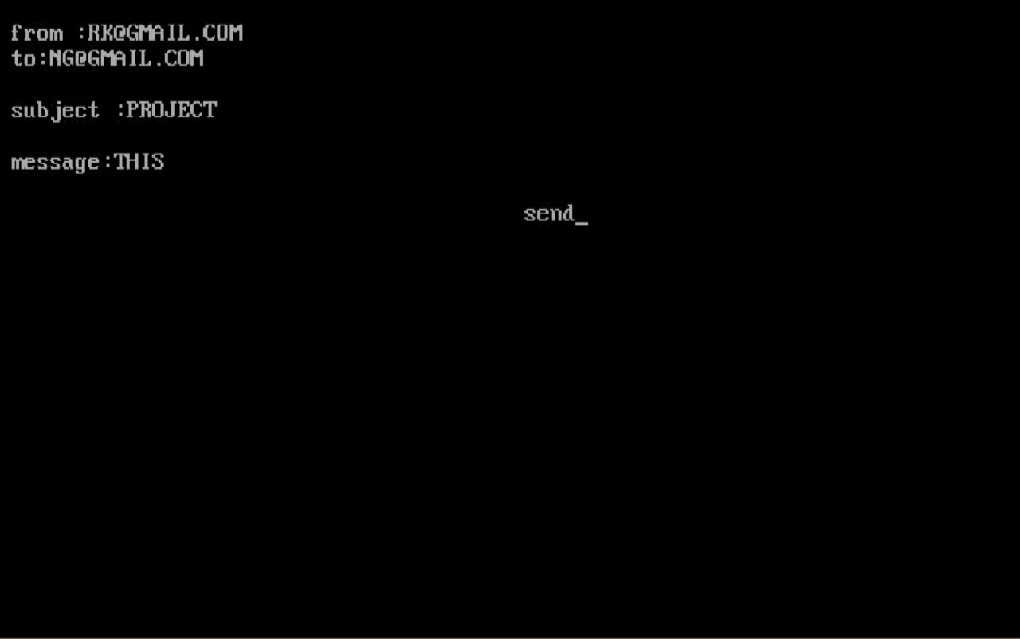

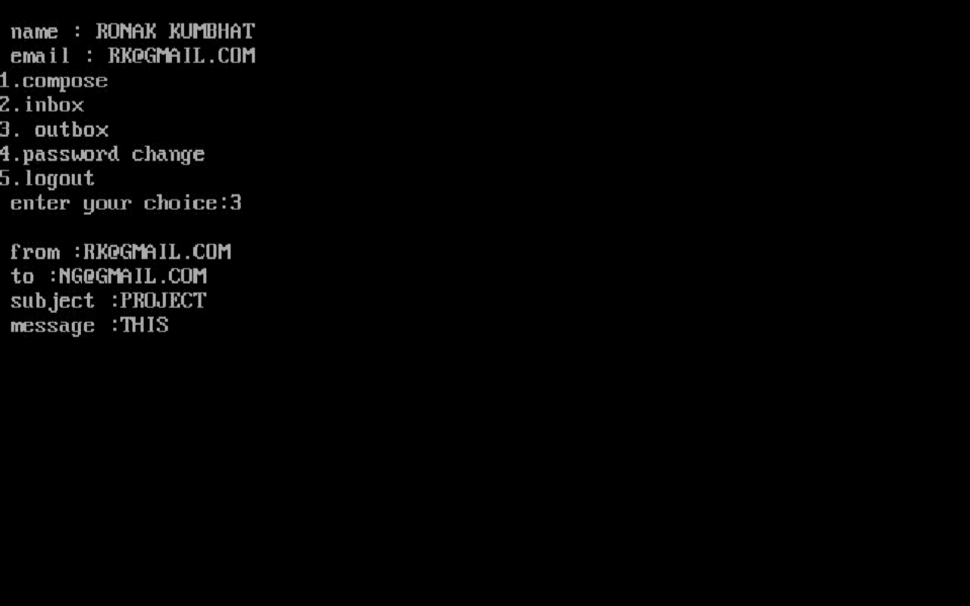

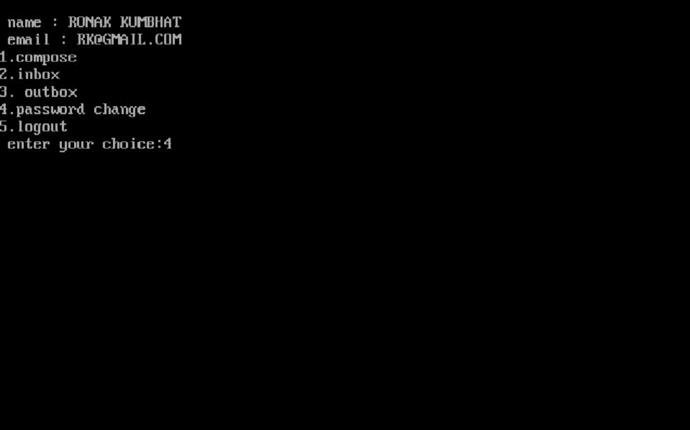

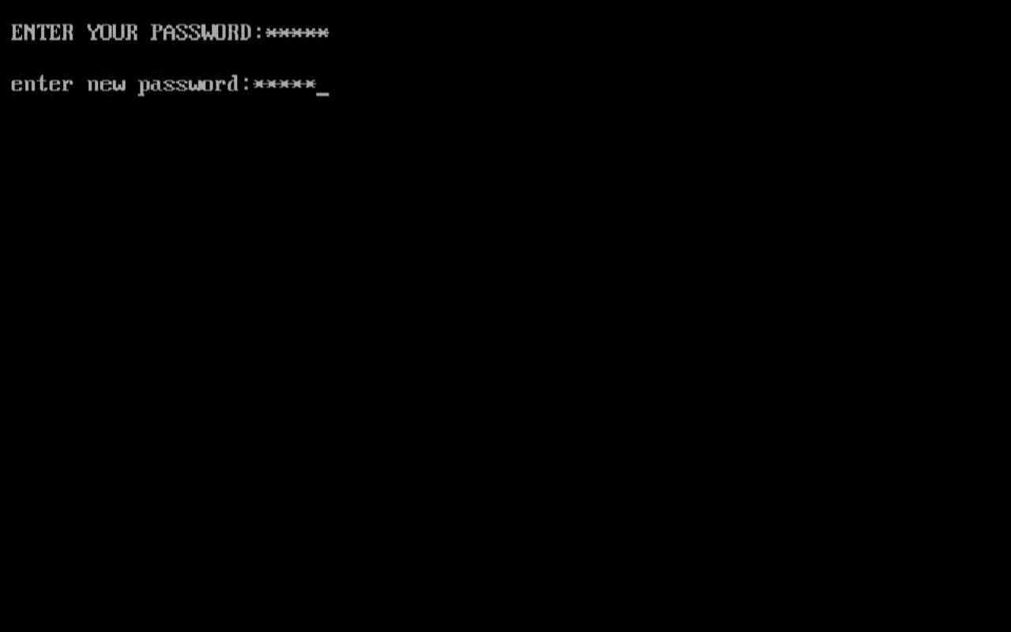

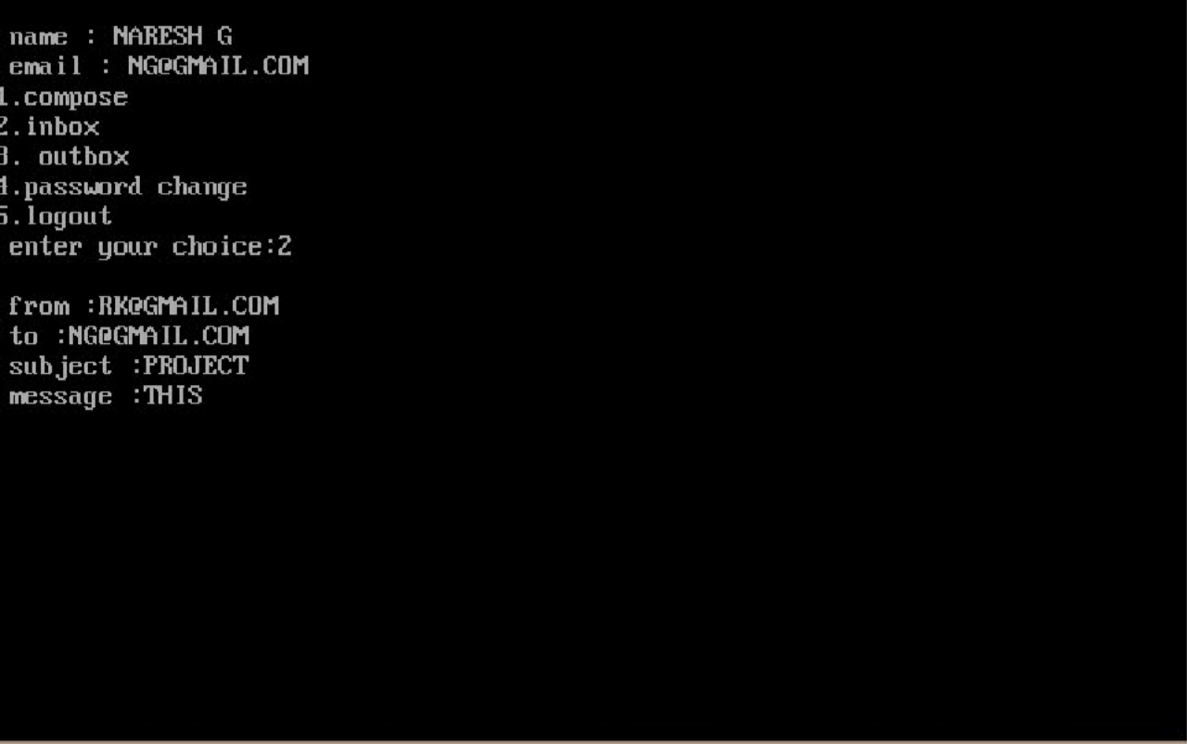

**CONCLUSION:**

* + Thus the program is successfully executed.
  + Now the email service is very useful to people as it acts as a communication device and people can enjoy it by chatting with other people.



# FUTURE ENHANCEMENT:

The program “email service” is just a prototype of the actual full version of the program. The further updates includes more accessibility and including various other options. The future enhancements will also include adding more attractive background using graphics and to make the service more attractive.



# BIBILIOGRAPHY:

1. [www.wikipedia.com](http://www.wikipedia.com/)
2. Computer science with C++ sumitaaroara
3. Object oriented programming by Robert lafore
4. [www.cbsesnip.com](http://www.cbsesnip.com/)

